*The naturally variable ELF3 polyglutamine is the hub of an epistatic network in Arabidopsis thaliana.*

Maximilian Oliver Press, Christine Queitsch

University of Washington Department of Genome Sciences

Seattle, WA 98195

Correspondence to queitsch@uw.edu

Running title: The ELF3 polyQ is an epistatic hub.

Keywords: ELF3, polyglutamine, short tandem repeat, microsatellite, epistasis, robustness

Correspondence to:

Christine Queitsch

Foege S-410  
Box 355065

Foege Building, Room S410B  
3720 15th Ave NE  
University of Washington  
Seattle, WA 98195-5065  
206-685-8935  
queitsch@uw.edu

**ABSTRACT**

Short tandem repeats are hypervariable genetic elements occurring frequently in coding regions. Their fast mutation rate has been recognized as a potent source of genetic variation contributing to adaptive evolution and the heritability of human disease. We recently proposed that such repeats are likely to mediate epistasis, by supplying compensatory mutations in certain genetic backgrounds. We have previously described one such case, in the *A. thaliana*gene *ELF3*, of a short tandem repeat that encodes a highly variable polyglutamine. In a twofold approach, we 1) dissected the genetic architecture of this incompatibility between two *A. thaliana*ecotypes, and 2) used a yeast two-hybrid strategy to identify proteins whose physical interactions with ELF3 were modulated by polyglutamine status. Using these two orthogonal approaches, we identify specific genetic and physical mechanisms by which the *ELF3*repeat may mediate the observed genetic incompatibilities. Our work elucidates a variety of mechanisms by which repeat variation, which is generally underascertained in population-scale sequencing, can control phenotypic variation. Furthermore, our work suggests that such highly variable loci contribute disproportionately to the epistatic component of heritability.

**INTRODUCTION**

It is often commented that evolution is not a designer but a tinkerer (Jacob 1977; Alon 2003). That is, adaptations are generally short-term, incremental fixes rather than alterations in fundamental biological plans. This principle is believed to underlie many design properties of biological systems. One source of genetic variation for such tinkering lies in short tandem repeats (STRs), genetic elements with elevated mutation rates. From these mutation rates, it is believed that STRs are thus more likely than substitutional variants to contribute adaptive variants on a per-locus basis (Kashi *et al.* 1997; Gemayel *et al.* 2010; Hannan 2010). It is also plausible that many (or most) adaptations are in fact compensations for other genetic variants (Szamecz *et al.* 2014). Consequently, it is expected that STRs are relatively likely to show epistasis with other loci, and this expectation is borne out in the handful of well-characterized STRs (Press *et al.* 2014).

One such STR resides in the *Arabidopsis thaliana* gene *ELF3*, where it encodes a polyglutamine that varies dramatically in length across different natural isolates (Tajima *et al.* 2007; Undurraga *et al.* 2012). We have previously shown that these *ELF3*-STR variants have strong effects on phenotype, but these effects differ depending on the genetic background hosting the variant in question (Undurraga *et al.* 2012). These observations suggest variants in the background modifying the effect of STR alleles through epistasis. The high variability of the *ELF3*-STR relative to expectations suggests that this STR may be compensating for variation in several genes across strains of *A. thaliana* (Carlson *et al.* 2015), according to epistatic variants specific to each strain. Previously, ELF3 was found to serve as a QTL affecting levels of “stochastic noise” in the phenotypes of recombinant inbred lines of *A. thaliana* (Jimenez-Gomez *et al.* 2011; Lachowiec *et al.* 2015). These observations invite comparison to known “robustness genes” such as Hsp90 (Sangster *et al.* 2007, 2008a; b), which act by revealing or concealing genetic variants affecting phenotypes. One potential mechanism of this robustness phenomenon is that such genes are highly connected in genetic networks. These previous observations lead to an expectation that *ELF3* lies at the center of epistatic networks determining phenotypic variation in *A. thaliana* phenotypes. However, it is not clear to what degree variation in the ELF3 polyQ may contribute to this phenotypic variation.

The ELF3 protein functions promiscuously as an adaptor protein in multiple protein complexes involved in a variety of developmental pathways (Liu *et al.* 2001; Yu *et al.* 2008; Yoshida *et al.* 2009; Nusinow *et al.* 2011; Chow *et al.* 2012). Consequently, a favorable hypothesis for why *ELF3*-STR variation affects phenotypes is that the encoded polyglutamine affects ELF3’s interactions with these other proteins. The ELF3 C-terminus, which contains the STR-encoded polyglutamine, is necessary for nuclear localization (Herrero *et al.* 2012) and ELF3 homodimerization (Liu *et al.* 2001), but only one other protein (Phytochrome Interacting Factor 4, PIF4) has been shown to interact with this domain of ELF3 (Nieto *et al.* 2014). These observations suggest naively that any effect of the ELF3-polyQ is likely to be derived from ELF3 protein-protein interactions mediating ELF3 nuclear localization or regulation of the PIF4 developmental integrator.

As an alternative hypothesis for how the ELF3 STR affects phenotype, one study of an intronic STR in *A. thaliana* demonstrated that certain hyperexpanded STR alleles led to dysregulation of the *IIL1* gene (Sureshkumar *et al.* 2009), presumably due to the difficulty of processing this expanded STR in *IIL1* transcripts. It is possible that, rather than modulating normal ELF3 function as an encoded polyglutamine, the ELF3-STR affects *ELF3* transcript or protein function. It has been previously argued that such ‘informational’ (as opposed to ‘operational’) genomic processes are more likely to have genetic or physical interactions (Jain *et al.* 1999). Therefore, it is not clear whether we should expect that the incompatibilities arise from altered ELF3-protein interactions, or whether they are the effect of altered processing of *ELF3* transcripts or proteins in different backgrounds.

In this study we dissect the epistatic landscape modifying the function of the *ELF3*-STR through both physical and genetic interactions, and present evidence that this STR forms the hub of a complex network of epistasis, likely due to its role as a compensatory modifier of many other loci. Furthermore, we present data suggesting that the altered protein-binding function of ELF3 is unlikely to fully explain the polyQ-mediated background effect.

**METHODS**

**Plant material and growth conditions:** Hypocotyl length was assayed in seedlings grown for 15d in incubators set to SD 22º on vertical plates as described previously (Undurraga *et al.* 2012). The *elf3-200* (Undurraga *et al.* 2012) and *elf3-4* (Hicks *et al.* 1996) mutants have been previously described. T-DNA lines (Alonso *et al.* 2003; Kleinboelting *et al.* 2012) were obtained from the Arabidopsis Biological Resource Center (Ohio State University).

**Genotyping:** For genotyping the *ELF3* STR and other loci across many F2 segregants, 1-2 true leaves from each seedling were subjected to DNA extraction as previously described [where?]. Seedlings were stored on their growth plates at 4º before genotyping but after phenotypic analysis. For the *ELF3* STR, PCR was performed in 10 µL volume containing 0.5 µM primers (Table S1), 0.2 µM each dNTP, 1 µL 10X ExTaq buffer, and 0.1 U ExTaq (Takara, Tokyo, Japan); with initial denaturation step of 95º for 5’, followed by 40 cycles of 95º 30”, 49º 20”, 72º 10”, with a final extension step at 72º for 5’. For other loci, PCR was performed in 20 µL volume containing 0.5 µM primers (Table S1), 0.2 µM each dNTP, 2 µL 10X ExTaq buffer, and 0.25 U Taq polymerase (NEB, Ipswich, MA); with initial denaturation step of 95º for 5’, followed by 35 cycles of 95º 30”, 55º 30”, 72º 1’, with a final extension step at 72º for 5’.

**Genome resequencing:** Plants selected for genotyping-by-sequencing were transplanted to soil and grown under LD for 2-3 weeks. They were then stored at 4º until DNA extraction was performed. One late rosette-stage Ws individual was used for Ws whole-genome resequencing. DNA extraction was performed using the DNeasy Plant Mini kit (Qiagen, Valencia, CA) according to the kit protocol. This DNA was quantified using high-sensitivity Qubit fluorescence analysis (ThermoFisher Scientific, Waltham, MA) and re-genotyped with *ELF3*-STR primers (Table S1). We used 10 ng DNA from each F2 segregant in NextEra transposase library preparations (Illumina, San Diego, CA), or a standard 50 ng preparation for the Ws library. Library quality was assessed on a BioAnalyzer (Agilent, Santa Clara, CA) or agarose gels. The Ws individual was sequenced in one 300-cycle MiSeq v2 run (300 bp single-end reads) to ~12X coverage. Ws sequence data was deposited with the 1001 Genomes Project (URL). The F2 segregant libraries were pooled and sequenced in one 200-cycle HiSeq v3 run to ~2X average coverage (100 bp paired-end reads, Table S3). F2 genotype data in VCF and QTL format are available as part of File S1.

**Sequence analysis:** Reads were aligned to the Col reference genome using BWA v0.7.5 MEM (Li 2013), and variants were called using SAMtools v0.1.19 (Li *et al.* 2009). High-quality Ws variants (Q>=40) were thus identified from Ws parent data, and compared with variants in previously-sequenced related strains (Gan *et al.* 2011). F2 segregant genotype calls were combined into a single variant call format (VCF) file and filtered for loci with such Ws variants. We used SNPtools (Wang *et al.* 2013) to perform haplotype and genotype imputation for each locus in F2 segregants. For workflows employed in sequence analysis, see Supplementary Text. Genotype data are provided in File S1. Following sequence analysis, one individual was found to be a heterozygote at the *ELF3* locus. This individual was omitted from all following analyses requiring *ELF3* homozygotes.

**Quantitative trait locus (QTL) analysis:** F2 genotypes were reduced to a set of 500 loci randomly sampled from the imputed genotypes, plus a single nucleotide variant (SNV) marking the *ELF3* locus. We used these genotypes to estimate a genetic map and perform QTL analysis using the R/qtl package (Broman *et al.* 2003). A nonparametric epistasis test was implemented in a custom R script using R/qtl functions. For a more detailed description of commands and the epistasis test, see the Supplementary Text. Follow-up genotyping of additional F2s was performed using PCR markers (Table S1), and these genotypes were included in subsequent QTL analyses.

**Candidate gene analysis:** Homozygous T-DNA lines (Alonso *et al.* 2003; Kleinboelting *et al.* 2012) with insertions in genes of interest were obtained from the Arabidopsis Biological Resource Center (Ohio State University) and phenotyped for hypocotyl length under SD at 15 days. All such experiments were repeated at least once. Double mutants were obtained by crossing relevant lines and genotyping (primers in Table S1). Mutant lines are listed in Table S2.

**Yeast two-hybrid:** *ELF3* variants with different STR lengths were PCR cloned out of cDNAs of previously described *A. thaliana* carrying *ELF3* transgenes (Undurraga *et al.* 2012) into the XmaI/BamHI sites of pGBKT7. Genes to be tested for ELF3 interactions were PCR cloned into the EcoRI/XhoI sites of pGADT7 from cDNAs of indicated strains (Table S1 for primers). Clones were confirmed by restriction digest and sequencing. The Y2H screen was performed against the Arabidopsis Mate and Plate cDNA library (Clontech, Madison, WI), essentially according to the manufacturer’s instructions, except selections were performed on C-leu –trp –his plates incubated at 23º. Clones which also showed activation of the *ADE2* reporter gene and did not autoactivate were subsequently tested against the various ELF3-polyQ constructs (see Supplementary Text for details, full details on clones given in File S2).

LacZ activity was assayed through X-gal cleavage essentially as previously described, again in strains using PJ69-4α as Matα parent (Möckli and Auerbach 2004). For weakly activating constructs (GLDP1 and ELF4), 0.2 absorbance units of yeast were used in each assay to reduce background, and color development was assessed at points between 16 and 72 hours of incubation at room temperature.

**Quantitative PCR (qPCR):** For measuring *ELF3* and *LSH9* transcript levels, pooled aerial tissue of ~30 mg short-day-grown seedlings of each relevant genotype were collected at ZT8 7d post germination. RNA preparation and qPCR was performed as described previously (Undurraga *et al.* 2012), using primers in Table S1.

**Statistical analysis:** All statistical analyses and plotting was performed using R 2.15.3 or R 3.2.1 (R Core Team 2015). Analysis scripts are provided as part of File S1.

**RESULTS**

To investigate the genetic architecture of epistasis for the *ELF3*-STR, we crossed two *A. thaliana* strains with a previously reported mutual incompatibility of their respective *ELF3*-STRvariants (Col-0, Ws, (Undurraga *et al.* 2012)). We generated an F2 population from this cross, which we phenotyped for variation in hypocotyl length under short days (SD), a trait dramatically affected by *ELF3* function. The Col and Ws backgrounds do not substantially differ in this trait (p = 0.16, Kolmogorov-Smirnov test, Figure 1A). We found that most F2s showed phenotypes within the range of the two parental lines, except that the F2 phenotypic distribution had a long upper tail of transgressive variation, and consequently a different distribution from either parent (p = 0.0039 against Ws, p = 0.055 against Col, Kolmogorov-Smirnov tests). Longer hypocotyls in light conditions indicate ELF3 dysfunction in the circadian clock (Liu *et al.* 2001), consistent with the co-segregation of incompatible Col and Ws alleles. These observations indicated that the previously observed *ELF3* background effect (Undurraga *et al.* 2012) was present in this segregating population. We next replicated this observation in a much larger population (1106 seedlings, Figure S1), which was used for further genetic analysis.

**Genetic analysis of *ELF3-*STR effects on hypocotyl length:** We investigated the genetic basis of the phenotypic transgression in hypocotyl length by harvesting the 720 most phenotypically extreme seedlings (longest and shortest hypocotyls) for genotyping (Figure S1). We genotyped each such individual at the *ELF3* locus, using primers directly ascertaining the 27bp *ELF3-*STR polymorphism between Col and Ws. Across these individuals, we observed a strong main effect of the *ELF3* locus on the phenotype (Figure 1B), in which the Col allele of *ELF3* is substantially more likely to show transgressive phenotypes implying incompatibility, though individuals homozygous for the Ws allele also show transgressive phenotypes.

Among these seedlings, much of the information about genetic effects of *ELF3* on hypocotyl length was contained in the individuals with extreme phenotypes, and individuals homozygous at the *ELF3* locus. *ELF3* genetic interactions are expected to be most apparent in *ELF3* homozygotes. Consequently, we used a novel genetic approach to detect epistasis between *ELF3* and other loci as follows. For each *ELF3* STRallele, we selected the 24 homozygotes of each sort (Ws/Ws and Col/Col) at each phenotypic extreme (the shortest and longest hypocotyls). The sampling of extremes is an effective and statistically justified method for genetic mapping (Lander and Botstein 1989). These 96 individuals were analyzed in a genotyping-by-sequencing approach (Table S3, Figure S1).



**Figure 1. Phenotypic transgression for 15d hypocotyl length under short days in Col x Ws F2 segregants.** (A): F2 segregant phenotypes compared to parents and an *elf3* mutant; n ≈ 50 for each homozygous line and n ≈ 100 for F2s. Colors indicate genotypes. (B): Phenotypic distributions of a large population of Col x Ws F2 segregants, for 720 extreme individuals genotyped at the *ELF3* locus. N = 1106 seedlings. 386 ungenotyped individuals fall into the region indicated by the black box.

We also resequenced the genome of the Ws (Wassilewskija) parent to ~12X coverage, calling 3.2*105 variants relative to Col, and used these variants as identifiers for Ws haplotype blocks. Comparisons of single nucleotide variants (SNVs) with related *A. thaliana* strains Ws-2 and Ws-0 yielded substantial overlap but also significant variation (Figure S2), indicating good SNV ascertainment. For each F2 individual, we mapped reads to the Col-0 reference and imputed haplotypes across each of the 96 individuals to identify chromosome blocks inherited from each parent Figure S3.

With this data, we performed a one-dimensional QTL scan to identify chromosomal regions contributing main effects to hypocotyl length (Figure 2A). This analysis indicated a peak on Chr2 corresponding to *ELF3* as expected, but also larger peaks on Chr1, Chr4, Chr5, and potentially one or more additional peaks on Chr2 affecting the phenotype. Ten additional F2s were genotyped by PCR around these peaks. A two-dimensional QTL scan suggested that at least some of these peaks interact epistatically with the *ELF3* locus (Figure S4).

We binned F2s homozygous at *ELF3* according to their *ELF3* genotype, and performed one-dimensional QTL analysis on each homozygote group separately (masking the genotypes of all other individuals). We observed that the same LOD peaks were replicated well in *ELF3*-Col homozygotes, but poorly in *ELF3*-Ws homozygotes (Figure 2B). Notably, Chr2 signal remained, indicating that the other loci on Chr2 are relevant to the phenotype (at least in *ELF3-*Col plants). This analysis suggested that the *ELF3*-STR genotypeis epistatic to the other loci controlling this phenotype, with effects masked in *ELF3-*Ws plants.



**Figure 2. QTL analysis identifies interactions of *ELF3* with multiple loci.** (A): one-dimensional QTL scan including all F2s. Horizontal line indicates 99% significance threshold based on permutations. (B): QTL scan stratified by ELF3 genotype (all genotypes but those of indicated F2s masked in each analysis). Horizontal lines of each color indicate 99% significance threshold based on permutations for each scan. (C): A direct nonparametric test of epistasis between *ELF3* and other loci, using the independent QTL scans shown in (B). ELF3 is located on chromosome 2. Dotted horizontal line indicates 99% significance threshold based on simulations.

To directly test for epistasis with *ELF3,* we adapted a previously described method (Sangster *et al.* 2008a). Separating the *ELF3* homozygotes again, we used permutations to define an empirical null distribution for the difference of likelihood (LOD) scores expected between the Ws and the Col scans. When comparing the difference in LOD scores between the two QTL scans at all loci, we found that the peaks on Chr1, Chr2, and Chr4 (and to a lesser extent Chr5) were all stronger in Col (Figure 2C). Consequently, these loci constitute background-specific *ELF3* interactors.

We considered the genetic contribution of these loci to the phenotype using a multiple QTL mapping approach, using both the independently estimated QTL locations and a refined model re-estimating QTL positions based on information from all QTLs (Table 4). In each case, strong effects on Chr1, Chr2, and Chr4 were supported, along with interactions between Chr2 (*ELF3*) and the other two loci. In the refined model, the Chr5 locus and a second Chr2 locus are also strongly supported. We conclude that while *ELF3* interacts epistatically with a variety of other loci in determining hypocotyl elongation, the principal contributors to ELF3-mediated effects on the trait are on Chr1 and Chr4. Inspection of the phenotypes of genotype combinations between *ELF3* and each locus supported the hypothesis of epistasis with *ELF3* for most QTLs (Figure S5).

**Candidate gene analysis:** The chromosome intervals identified by our QTL analysis were fairly large, as we were limited in resolution by the recombination events occurring in the sequenced segregants. These large intervals include a large number of potential candidate genes, and overlapped with a 1.8 MB inversion between these backgrounds on Chr4 (Rowan *et al.* 2015). Previous analyses mapping variation in hypocotyl length have detected loci in these regions and screened candidate genes for hypocotyl phenotypes (Khattak 2014).

We attempted to both replicate several such observations and investigate novel loci in the Col background under the conditions of our intercross experiment (15d SD hypocotyl length). We were able to confirm small phenotypic effects of T-DNA insertion mutants *lsh9* and *nup98* (Figure S6), but it is unlikely that these additive effects on their own explain the phenotypic variation in F2s (Figure 1A).

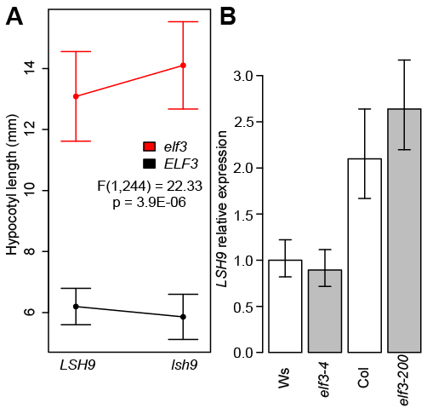

**Figure 3.** ***ELF3* shows a genetic interaction with *LSH9* and modulates its expression in a background-specific fashion.** (A): Double mutant analysis of *elf3* and *lsh9* seedlings grown 15d under SD. Statistics shown are from ANOVA analysis of the interaction between the mutant effects on phenotype. Error bars indicate standard deviation, n > 35 for each genotype. (B): Reverse-transcriptase PCR (RT-PCR) analysis of *LSH9* expression across genotypes. Seedlings were grown short days and harvested for RNA at ZT8 (dusk). *LSH9 e*xpression is expressed as a proportion of Ws expression, normalized relative to *UBC21*, error bars are standard error from three technical replicates. Experiments were repeated with similar results.

We generated double mutants between mutants affecting hypocotyl length and *elf3*, to establish whether these genes operated in the same pathway as *ELF3*. We found evidence for an interaction between *ELF3* and *LSH9*, in the form of reciprocal sign epistasis between the two null mutants affecting SD hypocotyl length (Figure 3A). While *lsh9* single mutants had slightly shorter hypocotyls than WT, *lsh9elf3* double mutant hypocotyls were longer than in *elf3* single mutants. We found no evidence for an interaction between *nup98* and *elf3* mutations (Figure S6C). LSH9 (LIGHT SENSITIVE HYPOCOTYLS 9) is an uncharacterized protein from a family of paralogs named for LSH1, which acts in light regulation of hypocotyl elongation (Zhao *et al.* 2004). Like other members of its family, it contains a putative nuclear localization sequence but few other distinguishing features. We were unable to detect a physical interaction between the Col or Ws variants of LSH9 and ELF3 using yeast two-hybrid (Y2H, Figure S7), suggesting that ELF3-LSH9 epistasis is not based upon a physical interaction between the two proteins. Levels of *LSH9* transcript were no different between WT and *elf3* mutants in either the Col or the Ws backgrounds relative to WT, but were reduced overall in the Ws background relative to Col (Figure 3B). Furthermore, *ELF3* expression levels were unchanged in *lsh9* mutants relative to Col (Figure S8). Consequently, *ELF3-LSH9* epistasis between Col and Ws may be due to regulatory changes between these two backgrounds altering *LSH9* transcript levels. This interpretation is consistent with the much stronger effect of this QTL in an ELF3-Col/ELF3-Col background (Figure S5). However, this epistasis is unlikely to be due to a direct physical or regulatory interaction.

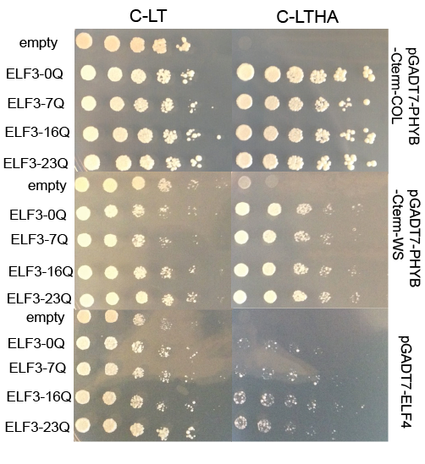

**Figure 4. Y2H interaction of ELF3 with known protein interactors can be modulated by polyQ variation.** Yeast carrying indicated vectors were spotted in five-fold dilutions onto C-leu-trp (C-LT) or C-leu-trp-his-ade (C-LTHA) media. PHYB-Cterm: previously-defined C-terminal truncations of PHYB sufficient for ELF3 interaction (Liu *et al.* 2001) from the Col and Ws backgrounds. For each protein X, experiments were repeated with independent PJ69-4α + pGADT7-X transformants with similar results.

**ELF3-polyQ variation’s effect on known protein interactions:** In parallel with our genetic analysis, we also used Y2H analysis to directly identify proteins whose physical interactions with ELF3 are polyQ-modulated. We first attempted to confirm that synthetic ELF3s with 0Q (no polyQ), 7Q (variant in Col), 16Q (variant in Ws), and 23Q (endogenous to strains Br-0 and Bur-0) forms of ELF3 show Y2H interactions with well-described ELF3 interactors ELF4 (Nusinow *et al.* 2011; Herrero *et al.* 2012) and PHYB (Liu *et al.* 2001) (Figure 4). None of the ELF3 constructs showed auto-activation in yeast also carrying an empty vector (Figure S9). The ELF3-interacting domain of PHYB has two coding variants between Col and Ws, and we thus tested both Ws and Col variants of this domain, and found that both forms showed apparently equal affinity with all polyQ variants of ELF3 (Figure 4A). ELF4, which has no coding variants between Col and Ws, interacted with all polyglutamine variants of ELF3 (Figure 4B), though rather weakly compared to PHYB. Under these conditions, a subtle apparent preference of ELF4 for longer polyQ variants (e.g. ELF3-16Q and ELF3-23Q) was repeatable.

Recently, it was reported that ELF3 interacts with the transcription factor PIF4 both in Y2H and *in planta* (Nieto *et al.* 2014). We were not able to replicate this finding for any ELF3-polyQ variant in our Y2H system (Figure S10A, or using an alternate strain background, Figure S10B), and were thus unable to evaluate effects of polyQ variation on ELF3-PIF4 interactions. Future work with alternate methods may reveal such effects.

Collectively, these data suggest that the ELF3-polyQ’s effect on ELF3 protein-protein interactions is more efficacious for marginal interactions, which are presumably more sensitive to structural variation in ELF3. However, to demonstrate that specific interaction differences play a role in previously described phenotypic effects of ELF3-polyQ variation, more work will be necessary.

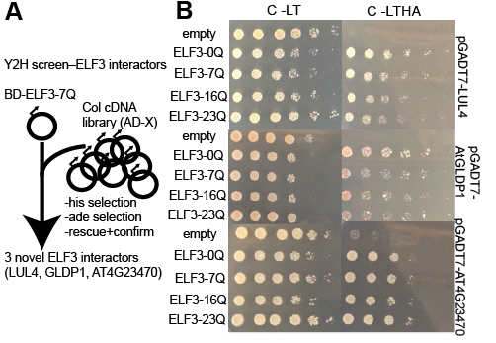

**Figure 5. Y2H screen identifies new interactors of ELF3.** (A): ELF3 Y2H screen design. (B): Yeast carrying indicated vectors were spotted in five-fold dilutions onto C-leu-trp (C-LT) or C-leu-trp-his-ade (C-LTHA) media. For each protein X, experiments were repeated with at least two independent PJ69-4α + pGADT7-X transformants with similar results.

**Y2H screen for new interactors:** None of these known ELF3 interactors were encoded by genes located in the major (Chr1, Chr4) QTLs identified by our genetic screen. If the ELF3-polyQ mediates protein interactions, we would expect that these regions contain additional, previously-undescribed ELF3 interactors which vary between the Col and Ws backgrounds. We screened the ELF3-7Q for interactions with proteins from a commercially available library derived from Col, to detect ELF3-protein interactions within the Col background (Figure 5A).

We subjected positives in the Y2H screen to several rounds of confirmation (Supporting Text), leaving a total of 3 robust, novel proteins interacting with ELF3: LUL4, AtGLDP1, and PLAC8-domain-containing protein AT4G23470. AT4G23470 was recovered in two independent clones, and LUL4 was recovered in three independent clones. The PLAC8-domain protein is encoded by a gene within the QTL interval on chromosome 4, but this protein showed no evident preference for any polyQ variant of ELF3, and thus differential interaction with this protein is unlikely to underlie the observed epistasis (Figure 5B). One protein, AtGLDP1, appeared to show a subtle preference for the ELF3-0Q construct over longer polyQs. While this screen is unlikely to exhaust hitherto-unknown ELF3 interactors, and all interactions require confirmation *in planta*, these data support a model in which the ELF3-polyQ does not dramatically affect ELF3’s interactions with other proteins. Other mechanisms for genetic interactions with any given loci are not informed by this Y2H analysis.

**Subtle variation in ELF3 affinity for other proteins mediated by polyQ variation:** Two proteins, ELF4 and GLDP1, showed slight variation among polyQ variants of ELF3 in the Y2H growth assay. Both proteins showed relatively weak interactions with ELF3, and thus it was difficult to quantify the effect of the ELF3-polyQ on these interactions by yeast cell growth under selection. We therefore assayed LacZ expression by the Y2H constructs directly and quantitatively by measuring X-gal cleavage (Figure S11). This assay supported subtle effects of the polyQ, with GLDP1 slightly preferring shorter polyQs (particularly the synthetic ELF3-0Q), and ELF4 slightly preferring longer polyQs (particularly ELF3-16Q). These results suggest that polyQ effects on interactions with other proteins, though small, may be important for metastable ELF3-protein interactions, although strong protein interactions (for example ELF3-LUL4, ELF3-PHYB) are apparently robust to polyQ variation.

**DISCUSSION**

The contribution of STR variation to complex traits has been speculated for some time to be considerable (Kashi *et al.* 1997; Press *et al.* 2014). Specifically, it is expected that STR variation may contribute disproportionately to the epistatic term of genetic variance, and the molecular mechanisms by which different STRs contribute are expected derive from their specific features. For instance, polyQ variation may be expected to affect the protein interactions (Schaefer *et al.* 2012) and the transactivation activity of affected proteins (Escher *et al.* 2000). In this study, we considered these questions in the case of the previously-described *ELF3* STR (Undurraga *et al.* 2012). We found that the genetic architecture of ELF3-dependent phenotypes is highly epistatic between the Col and Ws strains, leading to substantial phenotypic transgression in the phenotype of hypocotyl length. We identified several candidates for loci underlying the observed *ELF3* interaction, and confirmed that one gene (*LSH9*) showed a genetic interaction with *ELF3*. Next, we used Y2H screening of ELF3-protein interactions to investigate whether the molecular mechanism of *ELF3* STR effects could be disrupted protein interactions. We found evidence that variation in the STR-encoded ELF3 polyQ was sufficient to subtly modulate weaker ELF3-protein interactions, notably with the protein AtGLDP1. These findings support a model in which highly variable loci, in particular STRs, can contribute to the epistatic component of heritability through both direct and indirect functional interactions with other loci.

**Potential genetic interactors of ELF3:** We identified at least 3 QTLs showing genetic interactions with the *ELF3* STR in a Col x Ws cross. These QTLs generally did not coincide with obvious candidates. Previous work has, however, found QTLs in similar regions for hypocotyl traits (Khattak 2014). The confirmation of one genetic interaction (*LSH9*) in the Col background suggests that these QTLs underlie variants truly affecting hypocotyl length in tandem with *ELF3* STR variation. Further work will be necessary to more precisely map these variants.

**The ELF3-polyQ and physical protein interactions:** We applied an orthogonal method, Y2H, to study potential effects of polyQ variation on ELF3’s interactions with other proteins. ELF3’s promiscuous physical associations with other proteins are known to be essential to its functions in the circadian clock (Nusinow *et al.* 2011; Herrero *et al.* 2012) and flowering repression (Liu *et al.* 2001; Yu *et al.* 2008). Disruption of these interactions suggested an attractive mechanism by which ELF3 polyQ variation might affect ELF3 function. Assaying several known and novel ELF3-interacting proteins yielded evidence for a small effect of polyQ variation on metastable protein interactions, but no generic requirement for ELF3 polyQ status across proteins. Indeed, the modest effects that we found were protein-specific and thus not likely to generalize. We have, of course, not exhausted all possibilities for polyQ-dependent protein interactions, and our data must be considered provisional pending *in planta* analysis of interactions.

We do find that the ELF3-ELF4 interaction, which is crucial for circadian function and thus hypocotyl length (Nusinow *et al.* 2011; Herrero *et al.* 2012), demonstrates a subtle preference for the Ws 16Q ELF3 variant. The lack of sequence variation in ELF4 between Col and Ws and our failure to map the ELF4 locus by QTL analysis suggest that this difference alone does not underlie the transgressive phenotypes revealed by *ELF3*-STR variation (Figure 1A). However, the slight polyQ-dependence of the ELF3-ELF4 interaction could be important in higher-order interactions.

An alternative hypothesis is that ELF3-polyQ length is related to activation of regulatory targets of the EC. One point in favor of this hypothesis as the mechanism of ELF3-polyQ function is that relatively few of ELF3’s interactors have been shown to require the polyQ-residing C-terminus of ELF3. We do not address this hypothesis, though future experiments measuring EC occupancy at target promoters or target transcription under different polyQ regimes could provide some answers.

**ELF3 as a robustness gene:** An alternate hypothesis to direct, identifiable strong genetic interactions of ELF3 explaining polyQ-dependent genetic architectures is that there are many weak interactions that can be perturbed by hypomorphic ELF3 activity. In this interpretation, *ELF3* is a “robustness gene” (Lempe *et al.* 2013). The best-described example of such is in the protein chaperone HSP90 (Rutherford and Lindquist 1998), whose multiple interactions with proteins in a variety of signaling pathways (Taipale *et al.* 2012) lead to pleiotropic effects upon HSP90 inhibition or dysregulation (Sangster *et al.* 2007). ELF3 has been previously proposed as a robustness gene (Jimenez-Gomez *et al.* 2011), based on its promiscuity in protein complexes and the pleiotropic nature of *elf3* phenotypes. Our finding that functional modulation by polyQ variation reveals several genetic interactors supports this interpretation, though it is unclear whether the effects are strong enough to bear the comparison.

A similar hypothesis is that ELF3 “gates” robustness effects from robustness genes with which it interacts. For instance, we have recently shown that ELF3 function is epistatic to some of HSP90’s pleiotropic phenotypic effects [SETH PAPER], and ELF4 has also been proposed as a robustness gene governing circadian rhythms and flowering (Lempe *et al.* 2013). We suggest in this paper that polyQ variation affects ELF3-ELF4 binding, which would provide a mechanistic link between ELF3 polyQ effects and a known robustness gene.

These hypotheses remain speculative in the absence of more explicit tests. Nonetheless, we suggest that the pleiotropic effects of polyQ variation in ELF3 may be better understood by using robustness variation as a model.

**General implications for polyQ variation:** PolyQ variation is best-known for the role of certain polyQ hyperexpansions in human neurological disorders (Orr 2012). For instance, the degree of huntingtin polyQ expansion is strongly correlated with Huntington’s disease severity (Andrew *et al.* 1993). However, there are a variety of differences between the ELF3 polyQ and these cases. These hyperexpansions are often associated with protein aggregation or plaque formation, a phenomenon that requires a sufficiently long uninterrupted polyglutamine domain (Sharma *et al.* 1999; Lu and Murphy 2015). These previous *in vitro* studies suggest that although the ELF3 polyQ variants in Col and Ws are sufficiently different to alter phenotype, neither is long enough to lead to aggregation by these mechanisms (though the 23Q variant may be within this range). Furthermore, no ELF3-polyQ-related phenotype has been shown to have a monotonic association to ELF3 polyQ length. Indeed, all indications are that the mapping between ELF3 polyQ length and phenotype is (1) complex and (2) strongly contingent on genetic background, unlike the classic polyQ disease models. Remaining mechanistic hypotheses for observed phenotypic variation consisted of (1) modulation of protein-protein interactions by polyQ variation (Schaefer *et al.* 2012), (2) variation in trans-activation (Escher *et al.* 2000; Gemayel *et al.* 2015) between polyQ variants, or (3) polyQ variation leading to intrinsic variation in ELF3 protein or transcript instability. Our results suggest that hypothesis (1) may play a role, though its effects are not dramatic in our Y2H system. More work is needed to evaluate hypotheses (2) and (3) as mechanisms by which modest, sub-expansion polyQ variation affects phenotype generally.

**General implications for functional STR variation:** Efforts to appreciate the phenotypic effects of STR variation generally are as yet in their infancy, despite longstanding interest (Kashi *et al.* 1997; Fondon *et al.* 2008; Hannan 2010; Press *et al.* 2014). The few large-scale association studies so far suggest that STR contributions to heritable variation are potentially massive (Gymrek *et al.* 2015; Carlson *et al.* 2015). These contributions come from coding variation, transcriptional regulatory variation, and post-transcriptional regulation, with other as-yet-unknown mechanisms likely also playing a role. We have previously proposed that STRs with such functions can be identified both by phenotype association analyses and by direct analysis of selection. Specifically, we expect that STRs under diversifying selection (more variable than expected), like *ELF3*, are likely to contribute to heritability through genetic interactions rather than additive contributions. In this study, we provide data supporting this expectation, showing a variety of interactions between the *ELF3* STR polymorphism between Col and Ws and other loci. However, a single example is not enough support for such a broad hypothesis, and the exhaustive genetic analysis of more STR polymorphisms would be a welcome addition to our understanding.

**ACKNOWLEDGMENTS**

We thank Karla Schultz and Katie Uckele for technical assistance. We thank Choli Lee and Jay Shendure for assistance with high-throughput sequencing of the Col x Ws F2 population and members of the Shendure laboratory for advice regarding library preparation. We thank Amy Lanctot for generating the pGBK-ELF3-0Q and pGBK-ELF3-23Q constructs. We thank Daniel Melamed and Stanley Fields for guidance in carrying out Y2H experiments and the generous gift of yeast strains. We thank Giang Ong and Maitreya Dunham for access to the MiSeq instrument for resequencing the Ws genome. We thank Stanley Fields and Evan Eichler for access to LightCycler instruments. We thank Elhanan Borenstein and members of the Queitsch and Borenstein laboratories for helpful conversations.

**References**

Alon U., 2003   Biological networks: the tinkerer as an engineer. Science **301**: 1866–7.

Alonso J. M., Stepanova A. N., Leisse T. J., Kim C. J., Chen H., Shinn P., Stevenson D. K., Zimmerman J., Barajas P., Cheuk R., Gadrinab C., Heller C., Jeske A., Koesema E., Meyers C. C., Parker H., Prednis L., Ansari Y., Choy N., Deen H., Geralt M., Hazari N., Hom E., Karnes M., Mulholland C., Ndubaku R., Schmidt I., Guzman P., Aguilar-Henonin L., Schmid M., Weigel D., Carter D. E., Marchand T., Risseeuw E., Brogden D., Zeko A., Crosby W. L., Berry C. C., Ecker J. R., 2003   Genome-wide insertional mutagenesis of Arabidopsis thaliana. Science **301**: 653–7.

Andrew S. E., Goldberg Y. P., Kremer B., Telenius H., Theilmann J., Adam S., Starr E., Squitieri F., Lin B., Kalchman M. A., 1993   The relationship between trinucleotide (CAG) repeat length and clinical features of Huntington’s disease. Nat. Genet. **4**: 398–403.

Broman K. W., Wu H., Sen S., Churchill G. A., 2003   R/qtl: QTL mapping in experimental crosses. Bioinformatics **19**: 889–890.

Carlson K. D., Sudmant P. H., Press M. O., Eichler E. E., Shendure J., Queitsch C., 2015   MIPSTR: a method for multiplex genotyping of germline and somatic STR variation across many individuals. Genome Res. **25**: 750–761.

Chow B. Y., Helfer A., Nusinow D. A., Kay S. A., 2012   ELF3 recruitment to the PRR9 promoter requires other Evening Complex members in the Arabidopsis circadian clock. Plant Signal. Behav. **7**: 170–3.

Escher D., Bodmer-Glavas M., Barberis A., Schaffner W., 2000   Conservation of Glutamine-Rich Transactivation Function between Yeast and Humans. Mol. Cell. Biol. **20**: 2774–2782.

Fondon J. W., Hammock E. A. D., Hannan A. J., King D. G., 2008   Simple sequence repeats: genetic modulators of brain function and behavior. Trends Neurosci. **31**: 328–34.

Gan X., Stegle O., Behr J., Steffen J. G., Drewe P., Hildebrand K. L., Lyngsoe R., Schultheiss S. J., Osborne E. J., Sreedharan V. T., Kahles A., Bohnert R., Jean G., Derwent P., Kersey P., Belfield E. J., Harberd N. P., Kemen E., Toomajian C., Kover P. X., Clark R. M., Rätsch G., Mott R., 2011   Multiple reference genomes and transcriptomes for Arabidopsis thaliana. Nature **477**: 419–23.

Gemayel R., Chavali S., Pougach K., Legendre M., Zhu B., Boeynaems S., Zande E. van der, Gevaert K., Rousseau F., Schymkowitz J., Babu M. M., Verstrepen K. J., 2015   Variable Glutamine-Rich Repeats Modulate Transcription Factor Activity. Mol. Cell **59**: 615–27.

Gemayel R., Vinces M. D., Legendre M., Verstrepen K. J., 2010   Variable tandem repeats accelerate evolution of coding and regulatory sequences. Annu. Rev. Genet. **44**: 445–77.

Gietz R. D., Woods R. A., 2006   Yeast transformation by the LiAc/SS Carrier DNA/PEG method. Methods Mol. Biol. **313**: 107–20.

Gymrek M., Willems T., Zeng H., Markus B., Daly M. J., Price A. L., Pritchard J., Erlich Y., 2015 *Abundant contribution of short tandem repeats to gene expression variation in humans*. Cold Spring Harbor Labs Journals.

Hannan A. J., 2010   Tandem repeat polymorphisms: modulators of disease susceptibility and candidates for “missing heritability”. Trends Genet. **26**: 59–65.

Herrero E., Kolmos E., Bujdoso N., Yuan Y., Wang M., Berns M. C., Uhlworm H., Coupland G., Saini R., Jaskolski M., Webb A., Gonçalves J., Davis S. J., 2012   EARLY FLOWERING4 recruitment of EARLY FLOWERING3 in the nucleus sustains the Arabidopsis circadian clock. Plant Cell **24**: 428–43.

Hicks K. A., Millar A. J., Carre I. A., Somers D. E., Straume M., Meeks-Wagner D. R., Kay S. A., 1996   Conditional Circadian Dysfunction of the Arabidopsis early-flowering 3 Mutant. Science (80-. ). **274**: 790–792.

Jacob F., 1977   Evolution and Tinkering. Science (80-. ). **196**: 1161–1166.

Jain R., Rivera M. C., Lake J. a, 1999   Horizontal gene transfer among genomes: the complexity hypothesis. Proc. Natl. Acad. Sci. U. S. A. **96**: 3801–6.

Jimenez-Gomez J. M., Corwin J. a., Joseph B., Maloof J. N., Kliebenstein D. J., 2011   Genomic Analysis of QTLs and Genes Altering Natural Variation in Stochastic Noise (G Gibson, Ed.). PLoS Genet. **7**: e1002295.

Kashi Y., King D., Soller M., 1997   Simple sequence repeats as a source of quantitative genetic variation. Trends Genet. **13**: 74–78.

Khattak A. K., 2014   Natural Variation in Arabidopsis thaliana Growth in Response to Ambient Temperatures: PhD Thesis.

Kleinboelting N., Huep G., Kloetgen A., Viehoever P., Weisshaar B., 2012   GABI-Kat SimpleSearch: new features of the Arabidopsis thaliana T-DNA mutant database. Nucleic Acids Res. **40**: D1211–5.

Lachowiec J., Queitsch C., Kliebenstein D. J., 2015   Molecular mechanisms governing differential robustness of development and environmental responses in plants. Ann. Bot.: mcv151.

Lander E. S., Botstein D., 1989   Mapping Mendelian Factors Underlying Quantitative Traits Using RFLP Linkage Maps. Genetics **121**: 185–199.

Lempe J., Lachowiec J., Sullivan A. M., Queitsch C., 2013   Molecular mechanisms of robustness in plants. Curr. Opin. Plant Biol. **16**: 62–9.

Li H., 2013   Aligning sequence reads, clone sequences and assembly contigs with BWA-MEM. : 3.

Li H., Handsaker B., Wysoker A., Fennell T., Ruan J., Homer N., Marth G., Abecasis G., Durbin R., 2009   The Sequence Alignment/Map format and SAMtools. Bioinformatics **25**: 2078–9.

Liu X. L., Covington M. F., Fankhauser C., Chory J., Wagner D. R., 2001   ELF3 encodes a circadian clock-regulated nuclear protein that functions in an Arabidopsis PHYB signal transduction pathway. Plant Cell **13**: 1293–304.

Lu X., Murphy R. M., 2015   Asparagine Repeat Peptides: Aggregation Kinetics and Comparison with Glutamine Repeats. Biochemistry **54**: 4784–94.

Möckli N., Auerbach D., 2004   Quantitative β-galactosidase assay suitable for high-throughput applications in the yeast two-hybrid system. Biotechniques **36**: 872–876.

Nieto C., López-Salmerón V., Davière J.-M., Prat S., 2014   ELF3-PIF4 Interaction Regulates Plant Growth Independently of the Evening Complex. Curr. Biol. **25**: 187–193.

Nusinow D. A., Helfer A., Hamilton E. E., King J. J., Imaizumi T., Schultz T. F., Farré E. M., Kay S. A., 2011   The ELF4-ELF3-LUX complex links the circadian clock to diurnal control of hypocotyl growth. Nature **475**: 398–402.

Orr H. T., 2012   Polyglutamine neurodegeneration: Expanded glutamines enhance native functions. Curr. Opin. Genet. Dev. **22**: 251–255.

Press M. O., Carlson K. D., Queitsch C., 2014   The overdue promise of short tandem repeat variation for heritability. Trends Genet. **30**: 504–512.

R Core Team, 2015   R: A Language and Environment for Statistical Computing.

Rowan B. A., Patel V., Weigel D., Schneeberger K., 2015   Rapid and inexpensive whole-genome genotyping-by-sequencing for crossover localization and fine-scale genetic mapping. G3 (Bethesda). **5**: 385–98.

Rutherford S. L., Lindquist S., 1998   Hsp90 as a capacitor for morphological evolution. Nature **396**: 336–42.

Sangster T. a, Bahrami A., Wilczek A., Watanabe E., Schellenberg K., McLellan C., Kelley A., Kong S. W., Queitsch C., Lindquist S., 2007   Phenotypic diversity and altered environmental plasticity in Arabidopsis thaliana with reduced Hsp90 levels. PLoS One **2**: e648.

Sangster T. a, Salathia N., Lee H. N., Watanabe E., Schellenberg K., Morneau K., Wang H., Undurraga S., Queitsch C., Lindquist S., 2008a   HSP90-buffered genetic variation is common in Arabidopsis thaliana. Proc. Natl. Acad. Sci. U. S. A. **105**: 2969–74.

Sangster T. a, Salathia N., Undurraga S., Milo R., Schellenberg K., Lindquist S., Queitsch C., 2008b   HSP90 affects the expression of genetic variation and developmental stability in quantitative traits. Proc. Natl. Acad. Sci. U. S. A. **105**: 2963–8.

Schaefer M. H., Wanker E. E., Andrade-Navarro M. A., 2012   Evolution and function of CAG/polyglutamine repeats in protein-protein interaction networks. Nucleic Acids Res. **40**: 4273–87.

Sharma D., Sharma S., Pasha S., Brahmachari S. K., 1999   Peptide models for inherited neurodegenerative disorders: conformation and aggregation properties of long polyglutamine peptides with and without interruptions. FEBS Lett. **456**: 181–185.

Sureshkumar S., Todesco M., Schneeberger K., Harilal R., Balasubramanian S., Weigel D., 2009   A genetic defect caused by a triplet repeat expansion in Arabidopsis thaliana. Science **323**: 1060–3.

Szamecz B., Boross G., Kalapis D., Kovács K., Fekete G., Farkas Z., Lázár V., Hrtyan M., Kemmeren P., Groot Koerkamp M. J. A., Rutkai E., Holstege F. C. P., Papp B., Pál C., 2014   The Genomic Landscape of Compensatory Evolution. PLoS Biol. **12**: e1001935.

Taipale M., Krykbaeva I., Koeva M., Kayatekin C., Westover K. D., Karras G. I., Lindquist S., 2012   Quantitative analysis of HSP90-client interactions reveals principles of substrate recognition. Cell **150**: 987–1001.

Tajima T., Oda A., Nakagawa M., Kamada H., Mizoguchi T., 2007   Natural variation of polyglutamine repeats of a circadian clock gene *ELF3* in *Arabidopsis*. Plant Biotechnol. **24**: 237–240.

Undurraga S. F., Press M. O., Legendre M., Bujdoso N., Bale J., Wang H., Davis S. J., Verstrepen K. J., Queitsch C., 2012   Background-dependent effects of polyglutamine variation in the Arabidopsis thaliana gene ELF3. Proc. Natl. Acad. Sci. U. S. A. **109**: 19363–7.

Wang Y., Lu J., Yu J., Gibbs R. A., Yu F., 2013   An integrative variant analysis pipeline for accurate genotype/haplotype inference in population NGS data. Genome Res. **23**: 833–42.

Yoshida R., Fekih R., Fujiwara S., Oda A., Miyata K., Tomozoe Y., Nakagawa M., Niinuma K., Hayashi K., Ezura H., Coupland G., Mizoguchi T., 2009   Possible role of early flowering 3 (ELF3) in clock-dependent floral regulation by short vegetative phase (SVP) in Arabidopsis thaliana. New Phytol. **182**: 838–50.

Yu J.-W., Rubio V., Lee N.-Y., Bai S., Lee S.-Y., Kim S.-S., Liu L., Zhang Y., Irigoyen M. L., Sullivan J. A., Zhang Y., Lee I., Xie Q., Paek N.-C., Deng X. W., 2008   COP1 and ELF3 control circadian function and photoperiodic flowering by regulating GI stability. Mol. Cell **32**: 617–30.

Zhao L., Nakazawa M., Takase T., Manabe K., Kobayashi M., Seki M., Shinozaki K., Matsui M., 2004   Overexpression of LSH1, a member of an uncharacterised gene family, causes enhanced light regulation of seedling development. Plant J. **37**: 694–706.

**SUPPLEMENTARY INFORMATION – PRESS AND QUEITSCH 2016**

**SUPPLEMENTARY TEXT**

**Resequencing data processing.** Where appropriate, FASTQ files were demultiplexed according to barcodes (Table S3) using the illumina_demultiplexer.py script from the University of Idaho (<https://github.com/ibest/GRC_Scripts/blob/master/Illumina_demultiplexer.py>). Following alignment, duplicate removal, BAM conversion, and indexing, the following command was used to generate VCF files:

$ samtools mpileup -uf TAIR10.fas.masked [*.bam file list*] bcftools view -vcg - > [*output.vcf*]

Where TAIR10.fas.masked is the repeat-masked TAIR10 reference genome build in FASTA format.

For SNVs tagging differences between Col and Ws, SNVs from F2s were filtered for membership in the Ws SNV call set, >1.5X average depth across libraries, and overall allele frequency 0.3-0.7 across libraries. This yielded approximately 230,000 variants. VCFs were then split by chromosome for SNPtools analysis. For each chromosome, commands were run according to SNPtools documentation (<https://www.hgsc.bcm.edu/sites/default/files/software/SNPTools/V1_0/SNPTools-documentation-v1.1.pdf>).

SNPtools imputation was used to assign genotypes across this large set of variants to the various F2s, resulting in a final VCF file with genotype probabilities across each. This file was parsed into a simple genotype table, accepting the most probable genotype in each case. This table was used for QTL analysis and updated with selected PCR genotyping loci as indicated. Both VCF file and genotype table are provided in File S1.

**QTL analysis:** These genotypes were used for QTL analysis mapping the genetic basis of variation in hypocotyl length of segregants*.* Four loci were found to have strongly discordant genotypes (requiring many implausible recombinations), and were discarded before map re-estimation. Additional individuals were genotyped by PCR at informative markers and added to the analysis. One- and two-dimensional QTL analyses were performed using the commands *scanone()* and *scantwo()* using expectation-maximization to estimate effects (EM). Notably, for EM, it was necessary to include phenotypes of all phenotyped F2s (not just the extremes), with genotypes marked as missing, to avoid effect size overestimation. Interval mapping was performed with the *bayesint()* function. Multiple QTL mapping was performed with the *mapqtl()* function and refinement with the *refineqtl()* function.

The direct test for epistasis with *ELF3* was implemented in the following fashion. We computed the difference in LOD profiles across all loci between segregants homozygous for the Col vs. Ws alleles of *ELF3* (effectively, the difference between the two curves in Figure 2B)*.* This “delta LOD” profile captures the difference in apparent contributions of loci between segregants homozygous for each allele of *ELF3.* However, there is no obvious null distribution for this difference in profiles. Previously, this has been addressed by refitting QTLs to permuted phenotype data to estimate parameters of this null distribution (Sangster *et al.* 2008a). We chose a similar approach, though we elected to more conservatively use the permutation QTL differences directly to define a null distribution, which we used to set a nonparametric 1% confidence threshold across the entire profile (Figure 2C).

**Y2H screen:** pGBKT7-ELF3-7Q, pGBKT7-ELF3-16Q, pGBKT7-ELF3-0Q, and pGBKT7-ELF3-23Q were transformed into yeast strain AH109, and pGADT7-ELF4 was transformed into yeast strain Y187 (Gietz and Woods 2006), along with their respective empty vectors. These transformants were mated, and positive yeast two-hybrid (Y2H) interaction was confirmed on C-leu-trp-his (-LTH) plates incubated for 4-7d at 23º before continuing with the Y2H screen. >200 positive colonies from the screen were patched to C–LTH and C–Ade to confirm reporter activation, and true activating colonies were analyzed by insert PCR and sequencing. Transformants for each clone were mated to AH109 carrying pGBKT7 as an empty vector or with various *ELF3* inserts to test ELF3-prey interactions. We then tested each clone for independent activation of the *ADE2* reporter, which reduced this pool to 67 clones (tabulated in detail in File S2). Removing duplicates and clones carrying multiple plasmids, these represented 36 unique coding DNA sequences. Several clones expressed cDNAs corresponding to known ELF3 interactor ELF4. Prey plasmid inserts were isolated from yeast using the Zymo Research Yeast Plasmid Prep kit (Irvine, CA) and re-transformed into the Y187 strain. Clones showing positive activation with ELF3-7Q were further transformed into chemically competent TOP10 *E. coli*, prepared with the ProMega plasmid prep kit (Fitchburg, WI), and re-tested in Y187 and PJ69-4α. We were able to confirm interactions for 3 of these clones.

Each of these clones thus went through 5 rounds of confirmation. Results shown are from PJ69-4α as MATα parent, which showed more robust activation (grew on C-LTHA, which Y187 did not).

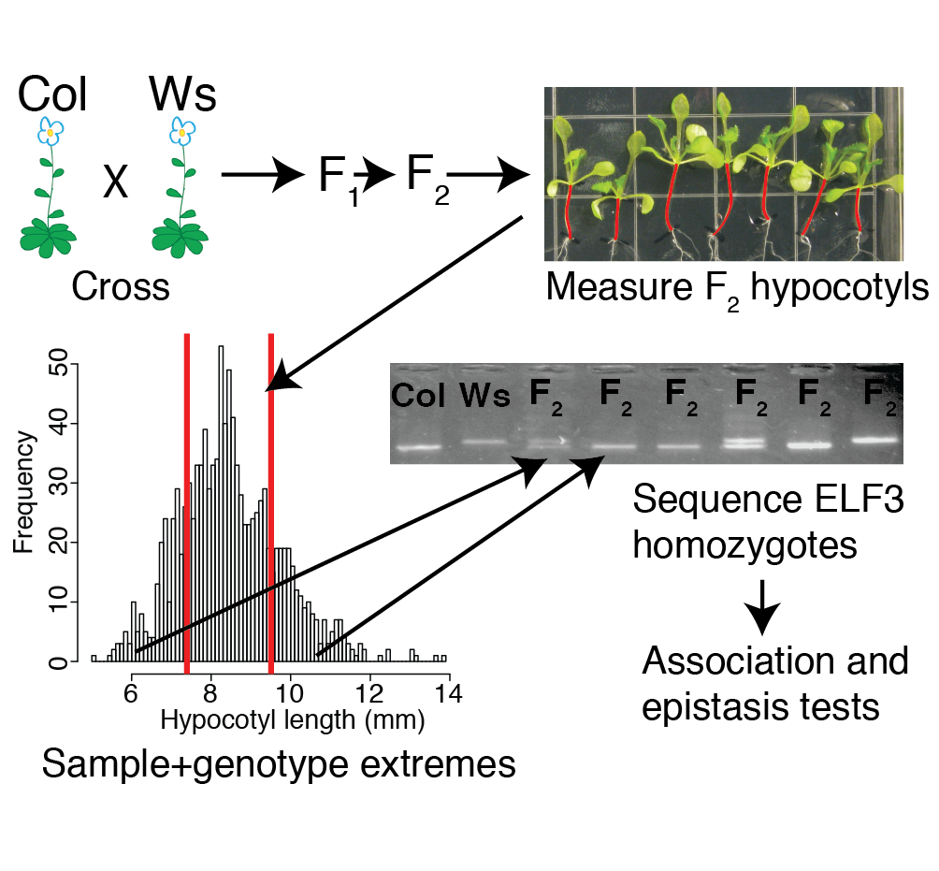

**Figure S1. Workflow for genetic analysis of the Col x Ws F2s.** Seedling plate image indicates hypocotyl length phenotype variation among Col x Ws segregants in red.Histogram shows phenotype distribution for Col x Ws segregants. Gel indicates different sizes of the *ELF3* STR between Col and Ws and in F2s.



**Figure S2. Overlap of high-confidence (Q>=40) single nucleotide variants (SNVs) observed in the Ws strain with two related strains.**

 

**Figure S3. Genotypes of the 96 extreme F2s used for sequencing**. Sorted vertically by descending phenotype (longer hypocotyls above, shorter hypocotyls at bottom), chromosomes are displayed along the X axis. ELF3-Col homozygotes at left, ELF3-Ws homozygotes at right. Red indicates homozygosity for Col allele, blue indicates heterozygosity, and green indicates homozygosity for Ws allele.



**Figure S4. 2-locus QTL scan indicates potential genetic interactions between *ELF3* and other loci.** Lower triangle indicates LOD for full model, upper triangle indicates LOD for interaction terms alone. *ELF3* corresponds to the locus on chromosome 2.

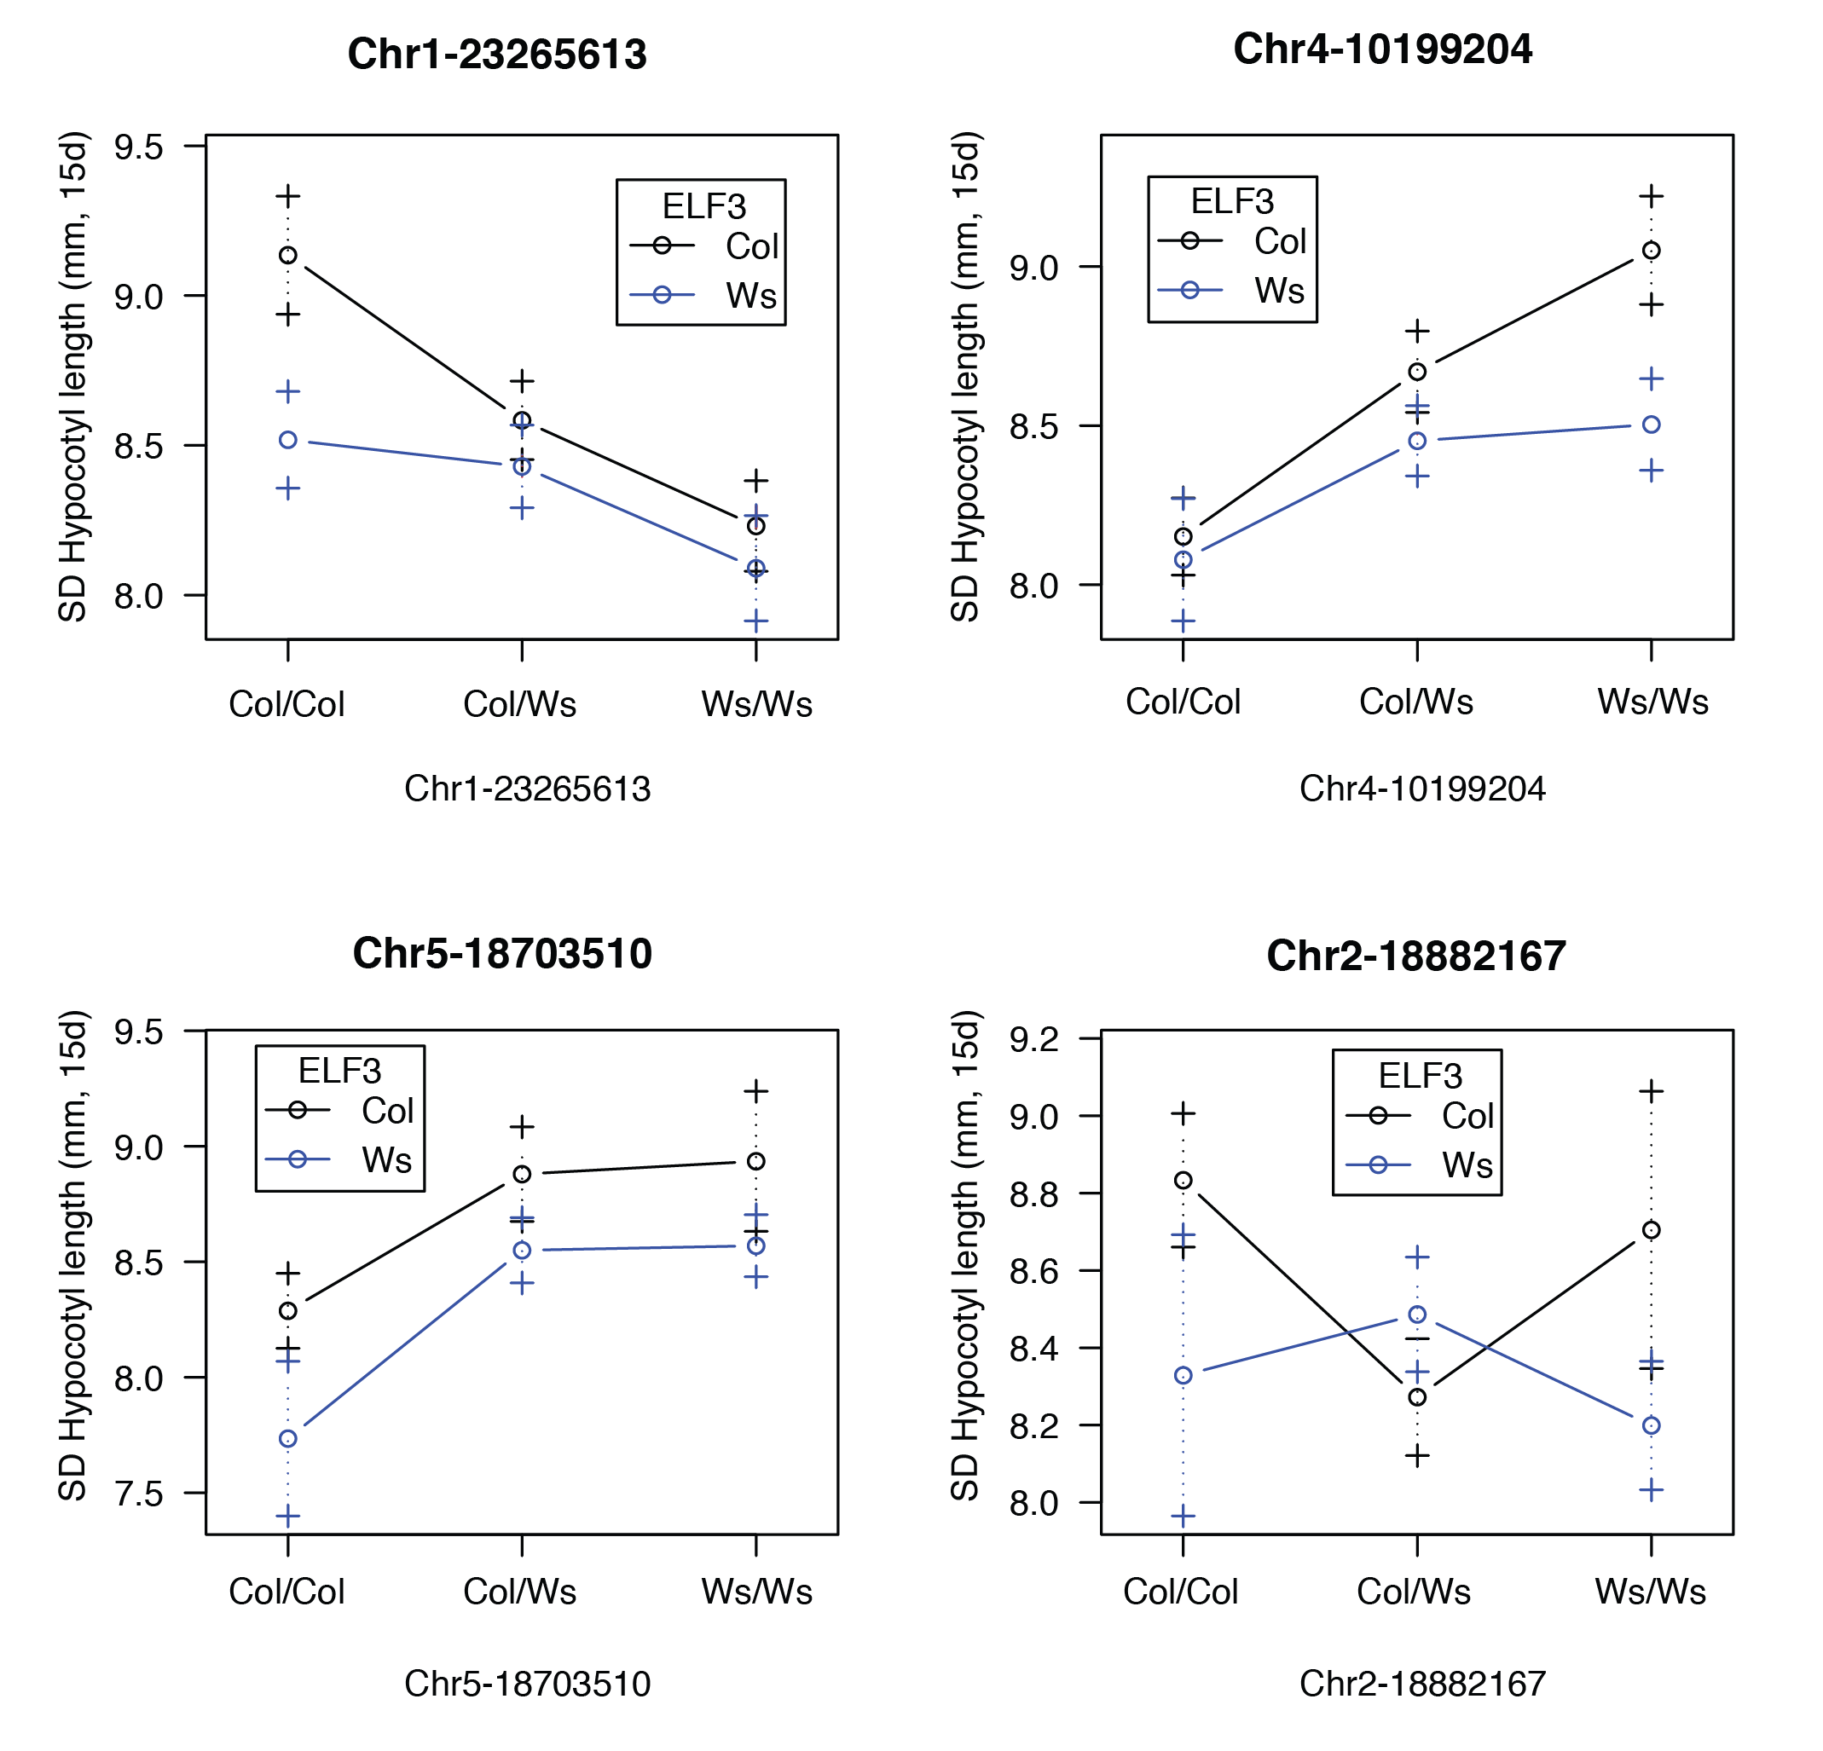

**Figure S5. Effect on hypocotyl length of various QTLs interacting with the ELF3 locus.** X-axis is non-*ELF3* locus, different lines indicate effects of other locus in different ELF3 backgrounds. Error bars represent standard error of the mean.

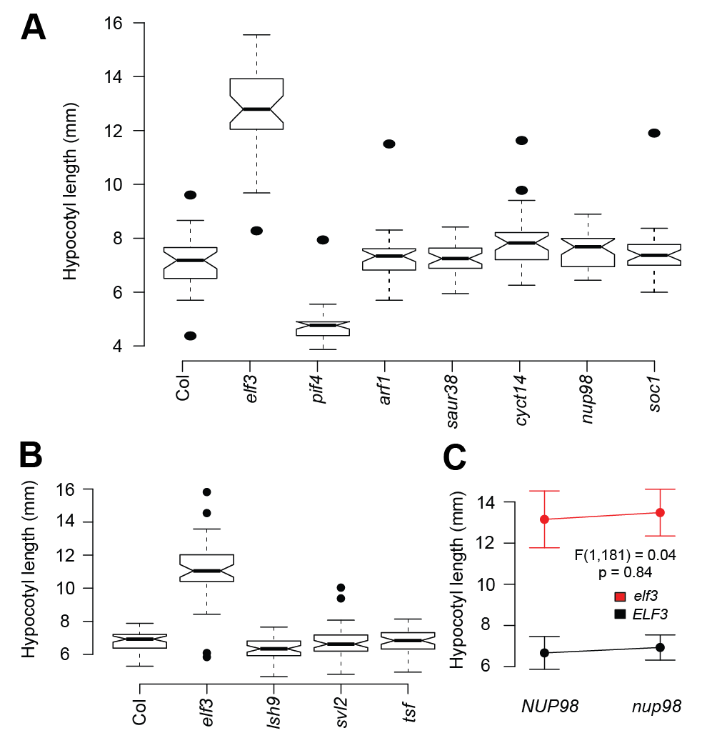

**Figure S6. Analysis of 15d hypocotyl length under SD of candidate gene mutants.** N ~ 50 for each line, each panel represents an independently conducted experiment, each repeated at least once with similar results. (A): Col WT, *lsh9*, *tsf*, *elf3*, *svl2*. Experiment was repeated with similar results. *lsh9* is ~0.5 mm shorter (p = 0.03, t-test), *elf3* is very elongated relative to WT (p < 2.2e-16, t-test). All others p > 0.1. N > 45 for each genotype. (B): Same as (A), but testing other candidates: *soc1*, *nup98*, *cyct1;4*, *saur38*, *arf1*, *pif4-2*, *elf3-200.* T-tests for differences vs. Col WT: p < 2.2e-16 for *pif4* and *elf3;* p = 0.009 for *cyct1;4*, p = 0.033 for *nup98*, p > 0.1 for all others. The *cyct1;4* T-DNA insertion could not be confirmed by PCR and was thus omitted from further analysis. (C): Double mutant analysis of *nup98* and *elf3* does not indicate a genetic interaction. Error bars indicate standard deviation; N > 40 for each group; F-statistic and p-value are displayed for testing the hypothesis of an interaction between the two genes in controlling phenotype.



**Figure S7. GAL4 DBD-ELF3 fusions do not lead to Y2H activation in combination with GAL4 AD-LSH9 vectors carrying either the Col or Ws variant of *LSH9*.** Yeast carrying indicated vectors were spotted in five-fold dilutions onto C-leu-trp (C-LT) or C-leu-trp-his-ade (C-LTHA) media. For each protein X, experiments were repeated with independent PJ69-4α + pGADT7-X transformants with similar results.

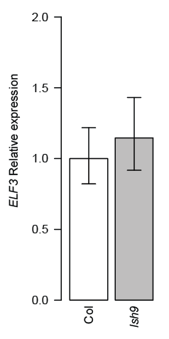

**Figure S8. *ELF3* expression is not substantially affected by *lsh9* T-DNA insertion.** *ELF3* expression was measured by PCR and normalized to *UBC21* expression (Col set to 1.0). Error bars are standard error of the mean from three technical replicates. This experiment was repeated with similar results.



**Figure S9. The GAL4 DBD-ELF3 fusion does not autoactivate in combination with a GAL4 AD-empty vector (pGADT7).** Yeast carrying indicated vectors were spotted in five-fold dilutions onto C-leu-trp (C-LT) or C-leu-trp-his-ade (C-LTHA) media. This experiment was repeated with an independent PJ69-4α + pGADT7 transformant with similar results.



**Figure S10. ELF3-PIF4 interaction not detectable in our assay.** Row labels of strains correspond to contents of pGBK vector expressing GAL4 DBD fusions. Label at right indicates GAL4 AD fusion expressed in strains. (A): Assays in AH109xPJ69-4α strain background, (B): Assays in AH109xY187 strain background. C-LT: YC-leu-trp media, C-LTH: YC-leu-trp-his media, YC-leu-trp-his-ade media. Y187 background showed activation with BD-ELF3 and AD-ELF4 and AD-PHYB (data not shown), but only on C-LTH. For each protein X, experiments were repeated with independent PJ69-4α/Y187 + pGADT7-PIF4 transformants with similar results.



**Figure S11. X-gal cleavage assay confirms modest differences in affinity between ELF3-polyQ variants for various proteins in Y2H.** Bar labels indicate the GAL4 DNA binding domain construct, either empty or containing ELF3 with various polyQ lengths. In each assay, all observations are expressed relative to the activity of the empty vector, whose mean is set to 0. Error bars indicate standard deviation across three technical replicates. This experiment was repeated with similar results.

**SUPPLEMENTAL TABLES**

**Table S1. Primers employed in this study.**

|  |  |  |  |
| --- | --- | --- | --- |
| **primer name** | **target** | **sequence** | **note** |
| nga111_F | chr1 mapping | TGTTTTTTAGGACAAATGGCG |  |
| nga111_R | chr1 mapping | CTCCAGTTGGAAGCTAAAGGG |  |
| nga280_F | chr1 mapping | GGCTCCATAAAAAGTGCACC |  |
| nga280_R | chr1 mapping | CTGATCTCACGGACAATAGTGC |  |
| nga168_f | chr2 mapping | GAGGACATGTATAGGAGCCTCG |  |
| nga168_R | chr2 mapping | TCGTCTACTGCACTGCCG |  |
| 1H1L-1.6_F | chr4 mapping | CTAGAGCTTGAAAGTTGATG |  |
| 1H1L-1.6_R | chr4 mapping | TTGAGTCCTTCTTGTCTG |  |
| g3883-1.4_F | chr4 mapping | TGTTTCAGAGTAGCCAATTC |  |
| g3883-1.4_R | chr4 mapping | CATCCATCAAACAAACTCC |  |
| nga129_F | chr5 mapping | CACACTGAAGATGGTCTTGAGG |  |
| nga129_R | chr5 mapping | TCAGGAGGAACTAAAGTGAGGG |  |
| rps4_NT_R | chr5 mapping | GGTACCTTTTCTTGTCAATG |  |
| rps4-NT_F | chr5 mapping | TCATCAATTTCCGTGGGGCA |  |
| cyct1;4 tdna confirm F | cyct1;4 | CTTTCCATTTTTCTCTTCCGG | failed |
| cyct1;4 tdna confirm R | cyct1;4 | TGGAATTTTGTTAACGATGGG | failed |
| ELF3 STR F (w ncoi site) | ELF3 | CCCTTC CCATGG GATTCCCACCTCCTGGTAAT |  |
| ELF3 STR R (w nari site) | ELF3 | TTTTGGGGCGCC GGTTCATTATCAGATCTCTG |  |
| ELF3 y2h cloning F | ELF3 | AG GCC GAA TTC CCG GGG ATG AAG AGA GGG AAA GA |  |
| ELF3 y2h cloning R | ELF3 | G CAG GTC GAC GGATCC TTA AGG CTT AGA GGA GTC ATA GCG |  |
| ELF4 y2h cloning f | ELF4 | G GAG GCC AGT GAATTC ATG AAG AGG AAC GGC GAG ACG AAA |  |
| ELF4 y2h cloning r | ELF4 | C ATC TGC AG CAT ATG C TTA AGC TCT AGT TCC GGC AGC ACC |  |
| lsh9 y2h clone f | lsh9 | G GAG GCC AGT GAATTC ATGTCTTCGGATCGTCACACACC |  |
| lsh9 y2h clone r | lsh9 | C ATC TGC AG C TCG AGC TCAAGTGAACGACTGATTAGGAG |  |
| lsh9_expr_f | LSH9 | CGGGTTCACTTGAGGGAAGTG | use with R lsh9 genotyping primer |
| lsh9-1 genotyping_r | LSH9 | CAAGTGAACGACTGATTAGGAGT |  |
| lsh9-1 genotyping_f | LSH9 | TTTTCGTGAATAATTCTCTCTCCC |  |
| nup98 tdna confirm f | nup98 | TTTTCTGAATTTTGGCTTTGTCTT |  |
| nup98 tdna confirm r | nup98 | AGTCTACACACATCCGTCTCTCCT/AGTCTACACACATCCGTCTCT |  |
| matchmaker insert amp F | pGADT7/ pGBKT7 plasmid insert | TCA TCG GAA GAG AGT AG |  |
| matchmaker insert amp R | pGADT7/ pGBKT7 plasmid insert | GTCACTTTAAAATTTGTATAC |  |
| phyb_cterm y2h clone f | phyb | GGAGGCCAGTCATATGATTGATGAGTTAGGTGCAGTTG |  |
| phyb_cterm y2h clone r | phyb | CATCTGCAGGGATCCCCTAATATGGCATCATCAGCATCAT |  |
| pif4 y2h cloning f | pif4 | GGAGGCCAGTGAATTCATGGAACACCAAGGTTGGAGTTTT |  |
| pif4 y2h cloning r | pif4 | C ATC TGC AG C TCG AGC CTAGTGGTCCAAACGAGAACCGTC |  |
| pif4-2 genotyping f | pif4 | ACCTCCTCAAGTCATGGTTAAGCCTAAGCC |  |
| pif4-2 genotyping r | pif4 | TCCAAACGAGAACCGTCGGT |  |
| saur38 tdna confirm f | saur38 | GATGGTTAGATCAATGGGCTG |  |
| saur38 tdna confirm r | saur38 | CCCCGATTCTCAATATTCACC |  |
| soc1 tdna confirm f | soc1 | AAGGATGAGGTTTCAAGCGTC |  |
| soc1 tdna confirm r | soc1 | TGGCGAATTCATAAAGTTTGC |  |
| svl2-1 genotyping | svl2 | GAGTGTGCATTTGTGTGAAG |  |
| svl2-1 genotyping | svl2 | ACGATGCGTTCTATGAGCAA |  |
| pif4-2 T-DNA primer | T-DNA | TAGCATCTGAATTTCATAACCAATCTCGATACAC |  |
| "o8474", lsh9-1 genotyping_tdna | T-DNA (GABI-KAT) | ATAATAACGCTGCGGACATCTACATTTT |  |
| tsf-1 genotyping lp | TSF | CGGTTAACTTGATTTTGTTTC |  |
| tsf-1 genotyping rp | TSF | ACGTGGACTCTCGTAGCACA |  |
| UBC21 expression f | UBC21 | GACCAAGATATTCCATCCTA |  |
| UBC21 expression r | UBC21 | GTTAAGAGGACTGTCCG |  |

**Table S2. Mutant lines employed in this study.**

|  |  |
| --- | --- |
| **mutant** | **identifier** |
| [*soc1 (Col-0):*](http://www.arabidopsis.org/servlets/TairObject?id=6530317492&type=germplasm) | SALK_138131C |
| *nup98 (Col-0):* | CS2103568 = GK-288A08-015346 |
| [*arf1-3 (Col-0):*](http://www.arabidopsis.org/servlets/TairObject?type=germplasm&id=1008491722) | CS24599 |
| [*pif4-2 (Col-0):*](http://www.arabidopsis.org/servlets/TairObject?id=6530293055&type=germplasm) | CS66043 |
| *saur38 (Col-0):* | SALK_001155 |
| [*cyct1;4 (Col-0):*](http://www.arabidopsis.org/servlets/TairObject?id=4856881&type=germplasm) | SALK_139322 |
| *lsh9 (Col-0)* | **CS328437** |
| *tsf (Col-0)* | [SALK_087522C](https://www.arabidopsis.org/servlets/TairObject?type=germplasm&id=4690110) |
| *elf3-200* (Col) | GABI750E02 |
| *elf3-4* (Ws) | [CS3790](https://www.arabidopsis.org/servlets/TairObject?type=stock&id=1000315897) |
| *svl2* (Col) | **SALK_057865** |

**Table S3. Col x Ws segregants analyzed by genotyping-by-sequencing.**

|  |  |  |  |  |  |  |  |  |  |  |
| --- | --- | --- | --- | --- | --- | --- | --- | --- | --- | --- |
| **Individual** | **barcode** | **reads mapped** | **genome coverage** | **growth plate number** | **plate position** | **d15 hypocotyl length** | **transplant tray** | **row (A-F)** | **column (1-12)** | ***ELF3 Col* alleles** |
| A1 | GACTTCGTA | 2295328 | 1.926477847 | 5 | 1 | 5.669 | BOTTOM1 | A | 7 | 0 |
| A2 | AATCTCGTC | 2558578 | 2.147424611 | 5 | 2 | 6.127 | BOTTOM1 | A | 8 | 0 |
| A3 | TCTTACGGT | 3331821 | 2.796410512 | 5 | 4 | 11.236 | TOP1 | B | 2 | 2 |
| A4 | TTGCCACTA | 2354351 | 1.976016084 | 5 | 5 | 9.591 | TOP1 | B | 3 | 0 |
| A5 | GCGTTAATG | 3567044 | 2.993834104 | 5 | 10 | 11.24 | TOP1 | B | 4 | 2 |
| A6 | CTTCAACGA | 1349755 | 1.132854697 | 6 | 9 | 7.457 | BOTTOM4 | A | 6 | 2 |
| A7 | AGCGTACTA | 2054778 | 1.724583283 | 7 | 5 | 11.136 | TOP1 | B | 7 | 2 |
| A8 | TGATCTGAG | 6217132 | 5.218063419 | 8 | 4 | 9.95 | TOP1 | B | 8 | 0 |
| A9 | TACGGTGAA | 2410759 | 2.023359541 | 10 | 6 | 9.611 | TOP1 | B | 11 | 0 |
| A10 | ATGCATGAC | 2645891 | 2.220706756 | 10 | 9 | 9.539 | TOP1 | B | 12 | 0 |
| A11 | AACTGTCCT | 2747651 | 2.306114326 | 11 | 3 | 6.543 | BOTTOM1 | B | 11 | 0 |
| A12 | AGACACCAT | 3354860 | 2.815747235 | 11 | 5 | 6.15 | BOTTOM1 | B | 12 | 2 |
| B1 | AGAACATCC | 1881398 | 1.579064765 | 14 | 5 | 6.347 | BOTTOM1 | C | 8 | 0 |
| B2 | CTGGATAAG | 2011360 | 1.688142384 | 16 | 4 | 6.33 | BOTTOM1 | D | 3 | 0 |
| B3 | GTGACTTAC | 3836304 | 3.219825084 | 17 | 7 | 6.014 | BOTTOM1 | D | 6 | 0 |
| B4 | CTCACTGAA | 1059679 | 0.889392766 | 18 | 7 | 10.985 | TOP1 | C | 9 | 2 |
| B6 | TGAGACATG | 2240186 | 1.880196949 | 19 | 2 | 7.147 | BOTTOM1 | D | 10 | 2 |
| B7 | TCCACGATT | 3525873 | 2.959279121 | 19 | 3 | 11.082 | TOP1 | C | 10 | 2 |
| B8 | GACTGATAC | 1643219 | 1.37916019 | 20 | 1 | 6.238 | BOTTOM1 | D | 11 | 0 |
| B9 | ACATCTGCT | 2702340 | 2.268084625 | 22 | 5 | 11.093 | TOP1 | D | 2 | 2 |
| B10 | ACGTTAGGA | 3353328 | 2.814461422 | 25 | 1 | 6.038 | BOTTOM1 | E | 9 | 0 |
| B11 | TGGACTGTT | 3052538 | 2.562007188 | 25 | 2 | 7.366 | BOTTOM1 | E | 10 | 2 |
| B12 | TTCTCAAGG | 4092160 | 3.434566035 | 26 | 2 | 10.628 | TOP1 | D | 9 | 0 |
| C1 | CAGGCTTAA | 2376433 | 1.994549594 | 26 | 8 | 5.687 | BOTTOM1 | E | 11 | 0 |
| C2 | GTGGTCTAA | 1971626 | 1.654793481 | 27 | 5 | 6.623 | BOTTOM1 | F | 2 | 2 |
| C3 | CACTAGACA | 1714651 | 1.43911335 | 27 | 7 | 6.099 | BOTTOM1 | F | 3 | 0 |
| C4 | CTCGATCTA | 2346675 | 1.969573587 | 27 | 8 | 5.841 | BOTTOM1 | F | 4 | 0 |
| C5 | TGGCATTCA | 2924555 | 2.454590551 | 28 | 8 | 7.356 | BOTTOM1 | F | 7 | 2 |
| C6 | ACATTGCAC | 159016 | 0.133462756 | 29 | 10 | 10.164 | TOP1 | E | 3 | 0 |
| C7 | TATGCCACT | 1974750 | 1.657415467 | 30 | 9 | 9.948 | TOP1 | E | 7 | 0 |
| C8 | ACCGATCAT | 1621564 | 1.360985064 | 34 | 4 | 6.036 | BOTTOM2 | A | 2 | 0 |
| C9 | AGGTAGACT | 3366856 | 2.825815526 | 34 | 8 | 7.093 | BOTTOM2 | A | 3 | 2 |
| C10 | CAGTTGATC | 3891209 | 3.265907068 | 35 | 8 | 13.69 | TOP1 | E | 11 | 2 |
| C11 | ACTACCGAT | 394870 | 0.331415949 | 36 | 7 | 6.536 | BOTTOM2 | A | 8 | 0 |
| C12 | CATCATACG | 455273 | 0.382112425 | 36 | 8 | 6.947 | BOTTOM2 | A | 9 | 2 |
| D1 | CGTCAGTAA | 2644128 | 2.219227064 | 37 | 5 | 6.455 | BOTTOM2 | A | 10 | 0 |
| D2 | TTACGACAG | 4586816 | 3.849732767 | 37 | 6 | 11.178 | TOP1 | F | 6 | 2 |
| D3 | ACCAGTTGA | 2617445 | 2.196831916 | 38 | 2 | 11.28 | TOP1 | F | 7 | 2 |
| D4 | GAGATCGAT | 2974369 | 2.496399638 | 38 | 5 | 10.384 | TOP1 | F | 8 | 0 |
| D5 | CATAGTTGC | 1776793 | 1.491269376 | 39 | 8 | 9.551 | TOP1 | F | 11 | 0 |
| D6 | GAAGTCATC | 1235929 | 1.037320086 | 41 | 3 | 7.123 | BOTTOM2 | B | 4 | 2 |
| D7 | TGTAACGTC | 410208 | 0.344289193 | 42 | 3 | 9.333 | TOP4 | D | 12 | 0 |
| D8 | TAGCAGATG | 618152 | 0.518817413 | 43 | 2 | 11.533 | TOP2 | A | 5 | 2 |
| D9 | CCGACTAAT | 2249982 | 1.888418771 | 44 | 4 | 7.572 | BOTTOM4 | E | 7 | 2 |
| D10 | AGTACGCTA | 6326180 | 5.309587836 | 47 | 5 | 7.401 | BOTTOM4 | F | 1 | 2 |
| D11 | ATTGCTTGG | 1483518 | 1.245122511 | 52 | 3 | 11.307 | TOP2 | B | 10 | 2 |
| D12 | CAATTACGG | 3716441 | 3.119223596 | 52 | 6 | 11.585 | TOP2 | B | 11 | 0 |
| E1 | GGCAATTCT | 3406103 | 2.858755688 | 53 | 9 | 11.33 | TOP2 | C | 4 | 2 |
| E2 | GTTACAGGT | 2893975 | 2.428924636 | 54 | 4 | 7.08 | BOTTOM2 | C | 11 | 2 |
| E3 | ACACTGATG | 1969162 | 1.652725436 | 54 | 10 | 7.558 | BOTTOM4 | F | 11 | 2 |
| E4 | TGAGGATTC | 74043 | 0.062144582 | 55 | 3 | 11.25 | TOP2 | C | 7 | 2 |
| E5 | GTATACAGC | 1951625 | 1.638006563 | 55 | 6 | 11.276 | TOP2 | C | 8 | 2 |
| E6 | ATAGCCTTC | 1523251 | 1.278470575 | 56 | 9 | 13.121 | TOP2 | C | 11 | 2 |
| E7 | ATCGATTCC | 360569 | 0.302626984 | 57 | 8 | 11.378 | TOP2 | D | 2 | 0 |
| E8 | ACCATAAGC | 1291511 | 1.083970278 | 60 | 10 | 11.106 | TOP2 | D | 8 | 2 |
| E9 | AATGCGTCA | 2193069 | 1.840651465 | 62 | 3 | 5.465 | BOTTOM2 | D | 9 | 2 |
| E10 | AGAATCGTG | 4479066 | 3.759297767 | 63 | 1 | 11.802 | TOP2 | D | 12 | 2 |
| E11 | GAGGCAATA | 6544234 | 5.492601418 | 63 | 2 | 6.727 | BOTTOM2 | D | 10 | 2 |
| E12 | CTCTGACTT | 2837854 | 2.38182206 | 63 | 7 | 7.325 | BOTTOM2 | D | 12 | 2 |
| F1 | CTCAGCTAT | 2162856 | 1.815293575 | 64 | 10 | 7.492 | BOTTOM5 | B | 1 | 2 |
| F2 | TTGTGAGCA | 803296 | 0.674209502 | 66 | 1 | 11.79 | TOP2 | E | 6 | 2 |
| F3 | TCAGAAGAC | 3080338 | 2.585339838 | 66 | 8 | 9.554 | TOP2 | E | 10 | 0 |
| F4 | AATCGGCAA | 3392517 | 2.847352904 | 68 | 1 | 6.247 | BOTTOM2 | F | 1 | 0 |
| F5 | GTATTCGAG | 2432555 | 2.04165301 | 71 | 2 | 7.447 | BOTTOM5 | B | 5 | 2 |
| F6 | TAGAAGCCA | 1147423 | 0.963036651 | 72 | 2 | 5.903 | BOTTOM2 | F | 10 | 0 |
| F7 | AATGGCCTT | 74709 | 0.062703558 | 72 | 4 | 7.5 | BOTTOM5 | B | 7 | 2 |
| F8 | GGTCAACTT | 1528117 | 1.282554628 | 72 | 7 | 9.469 | TOP5 | B | 7 | 0 |
| F9 | TCAGTTCAG | 1969461 | 1.652976388 | 74 | 6 | 6.274 | BOTTOM3 | A | 1 | 0 |
| F10 | TACACCTAG | 4598401 | 3.859456104 | 75 | 5 | 11.728 | TOP3 | A | 3 | 2 |
| F11 | CTAAGATGG | 2896390 | 2.430951555 | 76 | 7 | 6.275 | BOTTOM3 | A | 4 | 0 |
| F12 | ATGTCGTAG | 3236556 | 2.716454221 | 79 | 1 | 11.183 | TOP3 | A | 11 | 0 |
| G1 | CATGTTGGA | 2819706 | 2.366590372 | 83 | 10 | 10.927 | TOP3 | B | 12 | 2 |
| G2 | GATGATAGC | 1600038 | 1.342918207 | 84 | 10 | 7.129 | BOTTOM3 | B | 6 | 2 |
| G3 | TGAAGCTGT | 487191 | 0.408901329 | 85 | 3 | 9.945 | TOP3 | C | 3 | 0 |
| G4 | GCAATGACT | 2869408 | 2.408305456 | 86 | 7 | 7.122 | BOTTOM3 | B | 8 | 2 |
| G5 | TCGAGATCT | 80032 | 0.067171173 | 88 | 1 | 6.308 | BOTTOM3 | B | 10 | 2 |
| G6 | CAAGAGCAT | 4776085 | 4.008586986 | 89 | 6 | 9.568 | TOP3 | C | 8 | 0 |
| G7 | ACGCACTAA | 2346562 | 1.969478746 | 91 | 6 | 11.414 | TOP3 | C | 9 | 2 |
| G8 | GAACTAGGA | 1335094 | 1.120549662 | 92 | 9 | 10.626 | TOP3 | D | 2 | 0 |
| G9 | TAATGCACC | 2070382 | 1.737679782 | 92 | 10 | 9.545 | TOP3 | D | 3 | 0 |
| G10 | ATCCTCAGT | 572433 | 0.480445276 | 93 | 5 | 9.986 | TOP3 | D | 4 | 0 |
| G11 | TGACTGCTA | 3446213 | 2.892420169 | 93 | 8 | 9.61 | TOP3 | D | 5 | 0 |
| G12 | TTCGAGTGA | 677494 | 0.568623387 | 94 | 4 | 12.438 | TOP3 | D | 8 | 2 |
| H1 | CTGATTGGT | 2572313 | 2.158952451 | 94 | 5 | 9.509 | TOP3 | D | 9 | 0 |
| H2 | GTCCATATC | 2809401 | 2.357941345 | 94 | 7 | 5.843 | BOTTOM3 | C | 6 | 0 |
| H3 | GATCTCTCA | 1898536 | 1.593448756 | 95 | 1 | 6.764 | BOTTOM3 | C | 7 | 2 |
| H4 | CTAATGGCA | 165936 | 0.13927074 | 103 | 5 | 6.028 | BOTTOM3 | D | 8 | 0 |
| H5 | TGCGTTAGT | 1345594 | 1.129362354 | 103 | 7 | 9.381 | TOP5 | F | 1 | 0 |
| H7 | ATATCGACC | 1170512 | 0.98241534 | 105 | 3 | 13.88 | TOP3 | E | 12 | 2 |
| H8 | ATAACTCGC | 1359083 | 1.140683725 | 107 | 7 | 6.881 | BOTTOM3 | E | 7 | 2 |
| H9 | TACTCAGTC | 4314258 | 3.620973762 | 108 | 5 | 6.35 | BOTTOM3 | E | 9 | 0 |
| H10 | GGAGTATCT | 2714867 | 2.278598585 | 109 | 1 | 6.465 | BOTTOM3 | E | 10 | 0 |
| H11 | AACTCTAGC | 3458587 | 2.902805716 | 109 | 10 | 9.839 | TOP3 | F | 9 | 0 |
| H12 | CGCTACATT | 3893747 | 3.268037221 | 110 | 5 | 10.838 | TOP3 | F | 10 | 2 |
| B5 | CATTACGAG | 2578299 | 2.163976524 | 111 | 1 | 5.796 | BOTTOM3 | F | 4 | 0 |
| H6 | GTGCTACAT | 1661072 | 1.394144284 | 113 | 2 | 6.032 | BOTTOM3 | F | 12 | 0 |
|  | **Mean** | 2374934.3 | 1.993291757 |  |  |  |  |  |  |  |

**Table S4. Multiple QTL mapping results.**

|  |  |  |  |
| --- | --- | --- | --- |
| **Chromosome** | **Position** | **90% credible interval** | **LOD** |
| *Raw model* |  |  |  |
| 1 | 23265613 | (18260614 : 25453225) | 3.3 |
| 2 | 9920153 | (5758889 : 18882167) | 3.01 |
| 4 | 10199204 | (6295201 : 15296654) | 2.83 |
| 5 | 18703510 | (9072000 : 26544677) | 2.61 |
| *Refined model (from MQM)* |  |  |  |
| 1 | 1,589,277 | (292344 : ~30,000,000) | 14.5 |
| 2 | 10,906,049 | (10906049 : 11063324) | 17.03 |
| 2 | 13,973,428 | (11822190: ~17,000,000) | 5.12 |
| 4 | ~10,000,000 | (8873411 : 11578413) | 8.27 |
| 5 | 18,184,159 | (~17,600,000 : 19470953) | 7.05 |